ASSIGNMENT
COM-101
Introduction to C Programming
By
Adnan Kaisar Wani
Roll Number
2023a1r050
Semester
1st (A3)
Department Name
CSE



Model Institute of Engineering & Technology (Autonomous)
(Permanently Affiliated to the University of Jammu, Accredited by NAAC with “A” Grade)
Jammu, India

2023

1.Write a C program to find the sum of elements in an array.
Ans) Code
#include <stdio.h>
int main() {
int n, sum = 0;
printf("Enter the number of elements in the array: ");
scanf("%d", &n);

int arr[n];
printf("Enter %d elements:\n", n);
for (int i = 0; i < n; i++) {
scanf("%d", &arr[i]);
}

for (int i = 0; i < n; i++) {
sum += arr[i];
}

printf("Sum of elements: %d\n", sum);

return 0;
}

Output
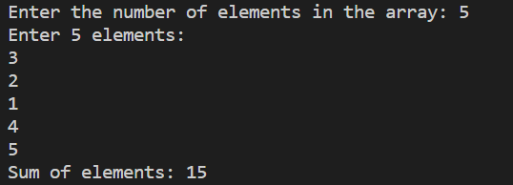

Q2) Write the program for calculator using elseif and do while.
Code
Sol) #include <stdio.h>
int main() {
char operator;
double num1, num2, result;
do {
printf("Enter an operator (+, -, *, /) or 'q' to quit: ");
scanf(" %c", &operator);
if (operator == 'q') {
break;
}
printf("Enter two numbers: ");
scanf("%lf %lf", &num1, &num2);
if (operator == '+') {
result = num1 + num2;
} else if (operator == '-') {
result = num1 - num2;
} else if (operator == '*') {
result = num1 * num2;
} else if (operator == '/') {
if (num2 != 0) {
result = num1 / num2;
} else {
printf("Error: Division by zero\n");
continue;
}
} else {
printf("Invalid operator\n");
continue;
}
printf("Result: %.2lf\n", result);
} while (1);
printf("Calculator closed.\n");
return 0;
}

Output
